OpenSocial Dev App
The OpenSocial Dev App gives you tools to test the OpenSocial JavaScript API and rapidly prototype OpenSocial applications.

Getting Started
This guide will give you a quick overview of the features available in the Dev App. Jump to any page as a reference, or use the navigation links to proceed through this guide in order.
- Code Tab
- News Tab
- Samples Tab
- Data Viewer Tab
- Export Tab

• New Features for MySpaceID Live!
From MySpace Developer Platform about 13 hours ago.
Greetings Developers!
Today the MySpace Open Platform team launched new functionality for MySpaceID and a remarkably useful set of MySpace ID SDKs. Other key updates in the release include fixes for Custom parameters on the callback function. Additionally, today MySpace announced the limited testing of a MySpaceID implementation on the Yahoo! homepage.
New MySpaceID Features:
- Activity Stream from Web sites using MySpaceID
MySpace Members' activities on MySpaceID-enabled Web sites can now be streamed to any site on the Web -- increasing engagement on partner sites. Partner sites can filter MySpace Members' activities by the activity feed type: photos, events, music, etc. For example, a photo-sharing site could choose to display activities specific to photo uploading, photo tagging, and photo album creation. We are currently Beta testing, but will have this API available to everyone soon.

- Easy authentication using OAuth and OpenID
Integration of both OAuth and OpenID into MySpaceID enables MySpace Members to securely login to MySpaceID-enabled Web sites using their MySpace credentials. The combination of OAuth and OpenID allows MySpace Members to bring their MySpace identity with them, solving the problem of username and password fatigue.

- New Application Developer Workflow
The modified MySpace Developer Workflow ("Create App") streamlines the process of building and configuring an application. Especially notable is its dedicated path for MySpaceID application development, which provides developers with “key” data needed to implement secure OAuth access tokens.
To begin, click the Build button in the blue navigation bar.

- MySpaceID SDKs - Developer toolkits demonstrate the "Open Stack" approach
MySpace introduces the Beta release of its MySpaceID SDKs for MySpace Open Platform Developers. Developers have been clamoring for toolkits and code examples for months, and they will undoubtedly be very excited about this SDK release, which is based on completely open Web standards. The client libraries are initially being released in PHP, Python, Ruby, .NET and Java, with additional libraries planned in the future for Cocoa and Android.
See the MySpaceID SDK page for an introduction and links to all SDK resources and documentation.

See the MySpaceID documentation for more information.
MySpaceID on the Yahoo! Homepage
The MySpace application is one of several new apps that Yahoo! recently began testing as part of its new Yahoo! homepage. The application enables users to check-in and keep up to date with the information and people they care about most. The launch marks a significant milestone for MySpaceID.
“The MySpace App, currently in testing on the new Yahoo! homepage, adds new social functionality into the Yahoo! experience by using MySpaceID to connect Yahoo! users to their MySpace network,” said Jason Oberfest, general manager of the MySpace Open Platform. "By logging into MySpace from the new App right on the Yahoo! homepage, users get quick access to their MySpace friend updates, friend requests, and can manage their MySpace status, mood and more – all while catching up on their other activities on Yahoo!” he explains. “By working with Yahoo! we have been able to take a big step forward in evolving the open Web. We are very pleased to be working with them.”
The new Yahoo! homepage is currently being tested by a small percentage of Yahoo! users in advance of a public beta. More information is available at: http://ycorpblog.com/2009/02/13/update-on-our-new-homepage-testing/.
With these enhancements, MySpace is the first major social network to have the full "Open Stack" implemented where information is flowing to partner Web sites based on completely open Web standards. MySpace now offers full OpenID support on every custom user URL.
MySpace is also the first major party to implement the new activity stream open specification.
• Introducing the OpenSocial Development Environment
From OpenSocial API Blog about 17 hours ago.
With the OpenSocial Development Environment (OSDE), you no longer need an online OpenSocial container environment to build your applications. OSDE is a new Eclipse plugin that lets you develop either OpenSocial JavaScript (gadget) client applications or OpenSocial Java client applications using OpenSocial 0.8's REST/RPC protocols, entirely within the Eclipse development environment.
OSDE is the creation of Yoichiro Tanaka, an expert software developer and leading pioneer in OpenSocial development from Japan. Yoichiro has also published a book on OpenSocial development in Japan.
Installing the OSDE plugin onto Eclipse 3.4.1 (or later) takes only minutes, and you can be up and running with a fully self-contained OpenSocial development environment. OSDE provides a complete social network environment in a single plugin, along with the necessary tools to easily manage your environment's social data. Additionally, you won't need to create multiple accounts on a social network for testing your applications. This can come in handy if you happen to feel inspired to create a new OpenSocial app while on a plane! 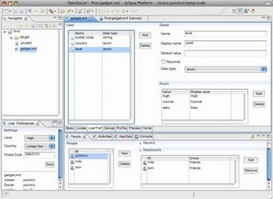
Architectural Highlights
OSDE is able to provide a complete, standalone development environment because it bundles the same code running on many OpenSocial containers today into a single Eclipse plug-in: for serving gadgets and OpenSocial data, Apache Shindig is bundled along with a compact Java H2 database, allowing for social data persistence. OSDE also uses Hibernate for Java Object Relational mapping of the OpenSocial data entities: people, activities, and data. Plus, OSDE bundles the OpenSocial Java client library so its wizards can quickly generate runnable Java client applications that use OpenSocial's REST/RPC protocols.
Feature Highlights
OSDE also includes development features that greatly enhance OpenSocial development:
- OpenSocial project creator wizards for both JavaScript/gadget client apps, as well as Java client applications that use the REST/RPC protocols.
- A re-entrant gadget specification editor that enables efficient editing of OpenSocial gadget properties, views, locale settings, user preferences as well as gadget and spec/JavaScript source code.
- An OpenSocial console view that shows the console output of the local Shindig/H2 social engine, as well as tabbed views for directly managing the onboard People, Activities and AppData persisted social data.
  - OSDE users can use the social database console to edit their own custom social data (such as people, friend relationships, activities etc.), or they can simply load the sample social data that comes with Apache Shindig's 'Sample Container' application.
For more information on how to use OSDE, checkout the OSDE tutorial (which includes a screencast) and visit the OSDE homepage.
Posted by Chris Schalk, Google Developer Advocate
• Build OpenSocial Apps for Social Change, Win Prizes
From OpenSocial API Blog about a day ago.
The Change the Web Challenge invites developers to create widgets and web applications that help people connect to opportunities to make a difference all over the web. It's a contest happening right now with $10,000 in prizes!
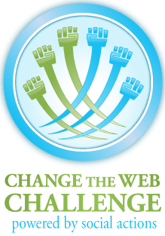
The Change the Web Challenge is being run by Social Actions - an aggregator of actions people can take to support causes, nonprofits, and progressive projects from more than forty different sites - like GlobalGiving, Change.org, DonorsChoose.org, Kiva.org, Idealist.org and VolunteerMatch. Social Actions then makes these actions available in a common format and API.
Now we’re looking to get those actions out there on the web sites, blogs and social networks we visit every day.
That's where OpenSocial comes in.
OpenSocial is the key to the social web. By enabling you to build apps that help people connect to actions on the most popular social websites like hi5, LinkedIn, MySpace, Netlog, Ning, orkut, and Yahoo! - you can help millions of people make a difference!
So the question we want to ask the OpenSocial community is:
What’s your dream idea for an OpenSocial app that helps people engage and interact around ways to take action?
Some ideas that might help get you started:
- An app that helps you find and share (and maybe show off) actions on your favorite OpenSocial social network.
- An app that enables you and your friends to compete to see who can take the most actions.
- An app that displays the hottest actions on your profile for the issues you care about.
Got an idea?
- Dig into the Developer Resources
- Join Social Actions Developers Google Group
- Check out apps already submitted to the Project Gallery
We're also hosting an online chat, OpenSocial for Social Change on Wednesday, March 25th (11am-12pm PST) with guests Dan Peterson (President, OpenSocial Foundation), Jay Parikh (Secretary, OpenSocial Foundation + Senior Vice President of Engineering at Ning) & Maxwell Newbould (Product Developer for MySpace OpenSocial) to explore and brainstorm how OpenSocial's framework and apps can help create a better world. The chat will be open to everyone to participate. Please RSVP here.
Posted by Joe Solomon, Director, Social Actions' Change the Web Challenge
• makeRequest Token Changes
From MySpace Developer Platform about 3 days ago.
[UPDATE: 03/18/09 - Best Caching Practices]
Later this week we'll be moving the token for makeRequest to the headers. Currently, the token changes with each page refresh. So each time a page loads, a new token is generated, which means the request to the proxy looks different each time. Because browsers typically cache data based on URL, the browser doesn't cache those requests to our proxy.
By moving the token out of the query string and putting it into a header, the URL will no longer vary on the token, and it won’t break the browser’s cache. To force the browser to not cache requests you can add a timestamp to the opensocial_url parameter. So if you normally pass up "http://example.com?a=b" into the opensocial_url param, you can now pass up "http://example.com?a=b&timestamp=832642837" (JS gives timestamps from var ts = (new Date()).getTime();).
Note, you will lose out on the performance benefits you get if you start adding timestamps to static resources (images, static help text files, etc.) that you know are not going to change between requests. In these instances, you should follow the general caching guidelines. Use timestamps only for dynamic content requests.
Currently...
Right now, makeRequests generate requests to our proxy that look like this:
http://api.msappspace.com/prox/relay.proxy?opensocial_token=hePEnfZPLj
/t8PYUN0FcSev4wNR9QPeudKuFfLVA6X96mZI+fbDP0Hta+6nOBH4H7JEdXhrZQv0+
q2PlIg7rxbm3CXDS94JfgbF/GtvgTtc=&opensocial_authtype=SIGNED&
opensocial_url=http%3A//www.causes.com/myspace/profile
HEADERS:
Accept: */*
Accept-Language: en-us
Connection: Keep-Alive
Content-Type: application/x-www-form-urlencoded
Referer: http://api.msappspace.com/apprendering/09092008120058/1_0_0/
render.app?opensocial_token=hePEnfZPLj%ft8PYUN0FcSev4wNR9QPeudKuFfLVA
6X96mZI%2bfbDP0Hta%2b6nOBH4H7JEdXhrZQv0%2bq2PlIg7rxbm3CXDS94JfgbF%
2fGtvgTtc%3d&opensocial_surface=profile.right&perm=%5b%22DP%22%2c%
22DH%22%2c%22UT%22%2c%22UF%22%2c%22RN%22%2c%22PB%22%
2c%22SN%22%5d&ownerId=183399670&viewerId=183399670&
installState=1&country=us&lang=en
UA-CPU: x86
Accept-Encoding: gzip, deflate
User-Agent: Mozilla/4.0 (compatible; MSIE 7.0; Windows NT 5.1; InfoPath.2; .NET CLR 1.1.4322; .NET CLR 3.0.04506.590; .NET CLR 3.0.04506.648; .NET CLR 3.5.21022; .NET CLR 2.0.50727; .NET CLR 3.5.30428)
Host: api.msappspace.com
Moving Forward...
So with this week’s code roll, the requests to our proxy will look like this:
http://api.msappspace.com/proxy/relay.proxy?opensocial_authtype=SIGNED&
opensocial_url=http%3A//www.causes.com/myspace/profile
Headers:
Accept: */*
Accept-Language: en-us
Connection: Keep-Alive
x-opensocial-authorization: OPENSOCIAL opensocial_token="hePEnfZPLj/
t8PYUN0FcSev4wNR9QPeudKuFfLVA6X96mZI+fbDP0Hta+6nOBH4H7JEdXhrZQv0+
q2PlIg7rxbm3CXDS94JfgbF/GtvgTtc="
Content-Type: application/x-www-form-urlencoded
Referer: http://api.msappspace.com/apprendering/09092008120058/1_0_/
render.app?opensocial_token=hePEnfZPLj%2ft8PYUN0FcSev4wNR9QPeud
KuFfLVA6X96mZI%2bfbDP0Hta%2b6nOBH4H7JEdXhrZQv0%2bq2PlIg7rxbm
3CXDS94JfgbF%2fGtvgTtc%3d&opensocial_surface=profile.right&perm=
%5b%22DP%22%2c%22DH%22%2c%22UT%22%2c%22UF%22%2c%22RN%
22%2c%22PB%22%2c%22SN%22%5d&ownerId=183399670&
viewerId=183399670&installState=1&country=us&lang=en
UA-CPU: x86
Accept-Encoding: gzip, deflate
User-Agent: Mozilla/4.0 (compatible; MSIE 7.0; Windows NT 5.1; InfoPath.2; .NET CLR 1.1.4322; .NET CLR 3.0.04506.590; .NET CLR 3.0.04506.648; .NET CLR 3.5.21022; .NET CLR 2.0.50727; .NET CLR 3.5.30428)
Host: api.msappspace.com
• Change the Web Challenge 2009!
From MySpace Developer Platform about 6 days ago.
Greetings Developers!
We're teaming up with Social Actions and we're challenging you to help change the world by changing the web! The Change the Web Challenge is all about making a difference by creating applications that promote social change.
Social Actions currently aggregates opportunities to make a difference from over 40 online platforms such as VolunteerMatch, Kiva.org, DonorsChoose.org, Idealist.org, and Change.org. We're looking for applications that will share these opportunities to take action on the websites, blogs, and social networks that people visit each day.
What does this mean for you? We're challenging MySpace Developers to create some great apps that make it easy for people to find and share opportunities to make a difference with their MySpace friends.
Social Actions is offering some great prizes including a first place prize of $5,000.
We will be, once again, promoting the best MySpace app as Editor's Pick for an entire week.
For more information on the Change the Web Challenge, see:
http://www.socialactions.com/changetheweb
You can also jump into Social Actions' Developer Resources and join the Social Actions Developers Google Group.
So think of a great app, and come help MySpace Change the WORLD by changing the WEB!!
Happy Coding!
Rhonda
• Weekend Apps Editor's Pick Announcement
From MySpace Developer Platform about 10 days ago.
Greeting Developers,
Thanks to all who attended the Weekend Apps event at Googleplex last month. I understand it was a huge success, and I know many people were developing MySpace apps for the first time.
As promised, two apps have been selected to receive a week (each) of Editor's Pick promotion. These apps were chosen from new MySpace apps created and submitted at the event. They are:
- Brain Chef
- Yumie Date
These Editor's Pick applications will be running in the Apps Gallery around the end of March along with our sponsored apps. Congratulations to the "chosen ones" and again, thanks to all of you who participated in creating brand new apps for MySpace at the event!
Rhonda
• Using templates and data pipelining for app profile view
From orkut Developer Blog about 14 days ago.
Posted by Vijaya Machavolu, orkut team
We're excited to announce the availability of server-side OS templates and data pipelining on the orkut sandbox. Data pipelining allows you to specify the data you want to use in your app, while templates let you describe how to render the app - all using a markup language (that's right, no JavaScript!). Using data pipelining and templates will reduce the number of round trips between the container and your server, making your app render faster. Moreover, template values are HTML-escaped thus plugging many XSS vulnerabilities automatically.

Since the profile view of an app doesn't require interactivity, server-side OS templates and data pipelining are a good fit for this view. We will soon be rendering apps that use these templates in the profile page. Our goal is to eventually allow only server-side OS templates in the profile view and at that point, all other active content including JavaScript and Flash will be stripped out when displaying the profile view of an app. We are confident that by leveraging these features, you will generate more usage for your apps, with reduced latency and make them safer for users.
These new features are currently available on the orkut sandbox, so you can start developing with them today. For more information (including examples), please see the OpenSocial Templates Developer's Guide , the OpenSocial Templates tutorial and the Data Pipelining tutorial. We know that OS templates are currently missing some capabilities that are required to build good profile views. At the top of our list are support for os:NavigateToView and ability to interpret JSON appdata. We'll be adding them soon.

Do check them out and give us your feedback.
• Test drive data pipelining and OpenSocial templates
From OpenSocial API Blog about 16 days ago.
OpenSocial v0.9 is coming right along, and we've prototyped some new features so that app developers can try them out. This stage in the iterative process is crucial to ensuring that containers are improving their OpenSocial platforms by adding the features that will make your apps more successful. Make your voice heard, and help improve the OpenSocial spec!
The first two prototypes to check out are data pipelining and OpenSocial templates. Data pipelining allows you to specify the data you want to use in your app, while templates let you describe how to render the app--all using a markup language (that's right, no JavaScript necessary!). Using data pipelining and templates will reduce the number of round trips between the container and your server, making your app render more quickly. Template values are also HTML-escaped, plugging many XSS vulnerabilities automatically.
Data Pipelining
To use data pipelining, add <Require feature="opensocial-data"> to the ModulePrefs in your gadget spec. Then you can specify the data that you want by adding request tags to a <Content> section of your gadget spec. For example, to access the viewer's friends, include a tag like this:
<script xmlns:os="http://ns.opensocial.org/2008/markup" type="text/os-data">
<os:PeopleRequest key="friends" userId="@viewer" groupId="@friends">
</script>
Note that you set the key attribute in the os:PeopleRequest so that you can access the data returned. You can use the data to render a template (as shown below) or access the data using JavaScript like this: opensocial.data.getContext().getDataSet('friends').
OpenSocial Templates
Once you've specified the data you need, you can use a template to display it. To enable templates in your app, include the following tags in your ModulePrefs:
<Require feature="opensocial-templates">
<Param name="process-on-server">true</param>
</Require>
Now you can add templates that define how to render social data. For example, to access the data specified above and print a list of the viewer's friends, include a template like this:
<script type="text/os-template">
<ul>
<li repeat="${friends}">
<span class="name" id="id${Context.Index}">${Cur.name.givenName}</span>
</li>
</ul>
</script>
This example illustrates several special variables in OpenSocial templates:
- repeat - iterate over the 'friends' object by adding the repeat attribute to the element.
- Context.Index - an index for the object being repeated.
- Cur - a reference to the current object. In this case that object is a JSON representation of a person so you can access fields directly.
These new features are currently available on the orkut sandbox, so you can try them out today. For more information (including a full example), visit the OpenSocial Templates page on the OpenSocial wiki. Once you've had a chance to check it out, please send a note to the spec list -- OpenSocial templates are designed to make app development easier, so let us know if we hit the mark.
Posted by Lane LiaBraaten, OpenSocial Team
• OpenSocial Weekend Apps
From OpenSocial API Blog about 20 days ago.
WeekendApps was like a codefest on overdrive organized by a grassroots team of 9 people - Sudha Jamthe, Shuchi Rana, Waleed Abdulla, Alexandros Pagidas, Van Riper, Max Marmer, Carol Tran, Jason Cooper and David Doolin. Over the course of the weekend, more than 200 designers and developers came together at the Googleplex in Mountain View, CA last Friday to form teams, brainstorm new concepts for social applications, and then design and launch new social apps.
After three days, 30 pizzas, 200 sandwiches, 40 trays of Asian food, 20 boxes of junk food, 400 cups of coffee, and 10 sessions from Amazon, Sun, Google App Engine, orkut, MySpace, Yahoo!Open Strategy, we saw 14 OpenSocial apps launch on MySpace and orkut and awarded prizes to 15 developers.
The air was charged all weekend
Everyone in attendance was focused throughout the weekend, creating teams, thinking up app ideas, workout through app flow and tech hacks, deciding which containers to use, and rushing to launch by Sunday night for the grand prizes.
The event kicked off on Friday with a keynote by Kevin Marks, followed by a panel of top OpenSocial developers discussing how they monetize their apps with Offerpal. Then the fun began: teams formed, and top developers Dave Westwood, Nicholas Talarico, Ben Chow, and Randal Truong helped provide feedback on the app ideas. The process helped everyone understand what makes a successful social app, and teams bonded after learning more about the various skillsets needed to build great applications.
Saturday workshops
The next day, Shuchi loaded us with coffee and bagels (thanks to Sun and Offerpal), then Mike Culver of AWS, Fred Sauer of Google App Engine and Ravi Kota of Sun/Joyent gave workshops on hosting options.
To start building apps, there were some, like me, who translated from the Facebook world of FBML and FQL and learned OpenSocial. There were others who had to quickly decide which OpenSocial container worked best for them. Dave Westwood of BuddyPoke drove home the point that the audience on each network is different, so it is wise to plan an app with the differences between containers in mind. Max Newbould of MySpace, Jason Cooper of orkut, and Eric of Yahoo spoke about each of their OpenSocial containers, and Kevin from Offerpal helped people build virtual currency into their apps for monetization. Each workshop raised thoughtful questions on comparing platforms, containers, scalability, and many different application scenarios. We often came to consensus around tough issues and engaged everyone in the audience.
It was also great to see the community working together. Many app developers received personal guidance to overcome product hurdles with help from MySpace's Max Newbould and Google's Jason Cooper, and MySpace's team went the extra mile to make sure apps got approved by the Sunday deadline.
Photo story by Shirley X. Lin
Find more videos like this on OpenSocial.org
Awards:
MySpace is giving developers another weekend to polish their apps and is going to announce two winners on Monday, March 2nd. These winners will be featured as Editor Picks on the MySpace directory. Dave Westwood offered 500K free impressions to six apps that went live on orkut, including YumieDate, Bollywood Music, Flash Cards, Product Envy, R U Clubbin? and Buddy Quiz!. Google also selected two winners, Buddy Quiz, for best product vision, and Bollywood Music, for best implementation using the Opensocial APIs. Both received two free Google I/O passes. Finally, Sun gave a lot of cool geek toys and restaurant cards to support the developers.
See all the launched apps at OpenSocial Weekend Apps.
Posted by Sudha Jamthe, WeekendApps co-organizer
Note: This post was updated on Feb 27th, 2009 to correct the list of winners and add the last name of one of the organizers.
• Gmail Labs gadgets now support OpenSocial APIs
From OpenSocial API Blog about 21 days ago.
A couple months back, the Gmail team added a few Labs experiments that let you add gadgets to Gmail's left nav. One of these experiments allows you to add any gadget by URL (i.e. pasting in the URL of its XML spec file). While the UI for adding gadgets is a bit klunky, people have already started building some interesting gadgets for Gmail.
Now Gmail supports OpenSocial APIs, so you can create social gadgets that make use of Gmail contacts. Gmail's contact manager has a few different groups (see screenshot below). The OpenSocial APIs use the 'Friends' group, the same list of of friends that the iGoogle sandbox uses.
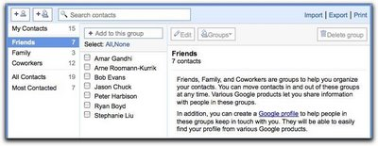Ready to try it out? To add a gadget to the left nav of your Gmail account, follow these steps:
- Go to the 'Labs' tab under Gmail Settings.
- Enable the 'Add any gadget by URL' experiment and click 'Save Changes.'
- Now you'll have a 'Gadgets' tab under Settings.
- Enter the URL of an OpenSocial gadget spec and click 'Add'.
Try adding the OpenSocial Dev app to take Gmail's OpenSocial support for a test drive. This gadget provides OpenSocial code samples that you can execute right in Gmail, as well as a 'Data Viewer' that will help you see what information you can access about people and friends.
Like all Gmail Labs, OpenSocial support is experimental and may change, break or disappear. You can find more info about Gmail's implementation of OpenSocial on the Gmail page of the OpenSocial wiki. If you have questions, please post them in the OpenSocial Application Development forum.
Posted by Lane LiaBraaten, OpenSocial Team
• Are you in the sandbox? Here's a quick way to check
From iGoogle Developer Blog about 23 days ago.
Can't figure out if your account is in the developer sandbox or not? Sometimes the "Welcome to the iGoogle Developer sandbox" message is obscured. Sometimes developers are confused about the behavior of the http://google.com/ig/sandbox page (which acts as a toggle, not just a redirect). And sometimes sandbox features aren't working properly, so that even if you are in the sandbox, it looks like you aren't.
Here's a small gadget to provide a little heads up on the sandbox status. If you're in the sandbox, it lets you know and gives you a quick way to leave. If you're not, it gives you a quick way to enter. And, finally, if it thinks you are in the sandbox, but features don't seem to be working, it tells you that, too. Think of it as your personal sandbox valet.
The exact behavior relies on the current rollout of features (and using the .com TLD), so it will likely need an update down the road as launches occur. Please test it, add it to your pages, and check the status message if things aren't working properly.
For questions and comments, feel free to add to this thread in the forum.
Posted by Dan Holevoet, Developer Programs
• OpenSocial App Developer Mentez Expanding into China
From OpenSocial API Blog about 27 days ago.
2008 was a great year for OpenSocial, with dozens of social networks all over the world adopting this standard as their technology of choice for open application platforms. This has greatly expanded the reach of OpenSocial applications to over 600 million users, and social app developers stand to benefit from this global expansion.
At Mentez, our goals are to create useful apps for consumers and to help international brands extend their reach. With OpenSocial, we have learned a lot about building social apps for global audiences, especially for users in Latin America, Europe and Asia.
Late in 2008 many top Chinese social networks, namely xiaonei, 51, MySpace.cn, Tianya, and YiQi all rolled out their support for OpenSocial. We helped sponsor OpenSocial hackathons in December in Beijing and Shanghai, China. Since then we have successfully migrated some of our applications such as 好友方格 (FriendGrid), Popularity, Soccermania to xiaonei and 51.com.
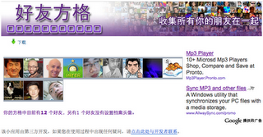Through this experience we have learned a lot about the market of Chinese social networks. For example, as app developers, it is very important to know who these users are. Xiaonei has a strong presence among university students while 51.com is especially popular with young people who frequent Internet cafes, each with over 30 million monthly active users.
A second critical stumbling block for foreign apps ported to Chinese containers is network latency. Finding local hosting can help here. We are currently on track for procuring servers inside China for large scale deployment as we execute on our goal in 2009 of reaching over 1 million users in China. Visit the OpenSocial wiki for more info on resources (e.g. hosting) about Chinese containers.
Another common issue that app developers face, especially on new social networks that support OpenSocial, is how to monetize. To this end we at Mentez bring a network of 200 developers and a strong team of business developers that let brands and their agencies integrate social channels and networks within their online strategy. Through our deep-rooted connections in advertising industry, we bring advertising dollars, especially from big brand names, to the application ecosystems on social networks, and we are looking forward to working with both social networks and app developers to enhance monetary value for the entire ecosystem.
As OpenSocial continues to take root and gains stronger adoption around the world, we look forward to many exciting opportunities in 2009 and beyond.
Posted by Juan Franco, CEO, Mentez
• MySpace Developer Platform Wiki
From MySpace Developer Platform about 29 days ago.
All MySpace Developer Platform (MDP) documentation is now available from one centralized location. We've recently revised a good majority of the existing content and have a lot of new documentation on the way.
Let's take a walk though some of the new features and changes to the MySpace Developer Platform.

Developer Platform Navigation Bar
The following has changed for navigation site-wide:
- Learn and Reference buttons replaced by a single Documentation button.
- Test button renamed Tools.
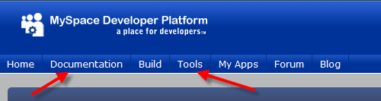

Developer Wiki Main Page
Our new Developer Wiki is accessible by clicking on the Documentation button in the blue site navigation bar.
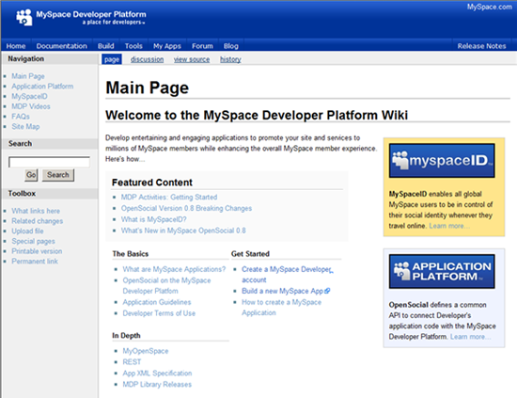
There are serveral methods to find documentation. Featured articles and categories are accessible from the Main Page:
- Featured Content – new and popular articles
- The Basics – introductory articles to learn about the platform
- Getting Started – set up a developer account and learn how to create a MySpace app
- In Depth – select links to detailed reference documentation

Left-hand Navigation
Direct links to Application Platform (OpenSocial) docs, MySpaceID docs, MDP Videos, FAQs and the Site Map are available throughout the Wiki from the left-hand navigation.
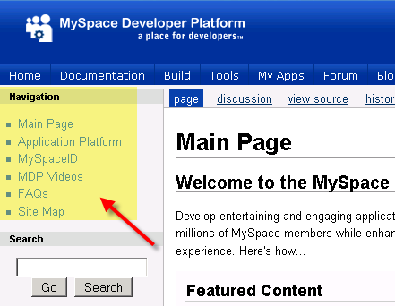

Site Map
Our new documentation Site Map updates automatically whenever content is assigned to a category.
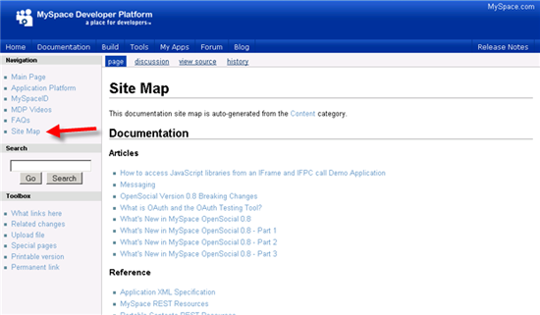

Search
Are you having trouble finding specific documentation on our site? Use the Search box in the left-hand navigation of the Wiki, type in a keyword for a complete list of related documents.
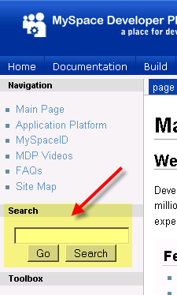

Content Navigation
Let's say you are reading "What's New in OpenSocial 0.8" by Chad Russell. Since document is the Articles category and the OpenSocial category, both paths are displayed at the top of the page.
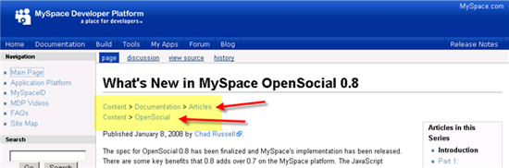

FAQ Index
We've revised and reorganized the entire FAQ into groups, then created an FAQ Index that will help guide you to the information, if available.
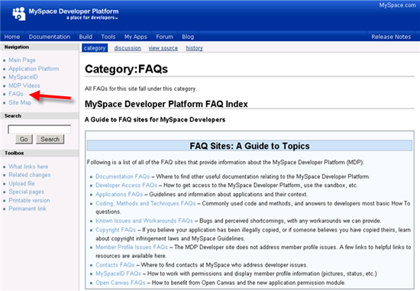

External contribution to the Wiki documentation is unavailable at this time. We are currently using our Wiki as a powerful collaboration tool between teams within MySpace to provide higher quality, accurate documentation for developers.
Questions, comments, feedback and suggestions are always welcome!
Jonathan Kramm
• Running JavaScript on Startup in OpenSocial
From MySpace Developer Platform about a month ago.
I recently had the opportunity to help some folks debug some odd errors in their JavaScript handlers. I discovered that there was some misunderstanding about how to run JavaScript when a gadget was loaded. There are so many ways to do things and each of these options has tradeoffs. The options are:
- Directly invoke the function(s) as soon as the JavaScript is loaded and parsed. This option can have timing issues depending on what other functions are called and what parts of the HTML DOM need to be loaded.
- Immediately schedule an event that then waits for the window to load. Here, one needs to worry about event chaining, which can be hard to understand.
- Wait for the container to signal that the container has loaded and let it handle running any onload handlers.
As we look at these options, it is important to remember how JavaScript runs within the browser:
- JavaScript ALWAYS runs as soon as the browser sees the JavaScript.
- The browser loads external JavaScript immediately, before processing parts below the script in the document.
What does this mean to us? It means that we need to understand when we can run code and when we should wait. A lot of the code we write executes some time after the page has loaded. Button clicks, mouse detection, changes to lists, and so on all happen after the page has loaded. Other code needs to run immediately. It seems that we tend to make mistakes with the code that needs to run right now. To avoid these mistakes, we need to understand what decisions we are making when picking an option.
Imagine that a we want to fill in a div tag named userData with the current user's name. To accomplish this task, we might write the following code:
<script type="text/javascript">
var dataRequest = opensocial.newDataRequest();
var ownerReq = dataRequest.newFetchPersonRequest(opensocial.IdSpec.PersonId.OWNER);
dataRequest.add(viewerReq, 'owner');
dataRequest.send( function(data){
var viewer = data.get('owner').getData();
document.getElementById('userData').innerHTML = viewer.getDisplayName();
});
</script>
The preceding code assumes that have the following markup somewhere on the view:
<div id="userData"></div>
So long as the preceding markup appears before the script, we are always OK. If the callback function happens after the markup is added to the HTML DOM, we are still OK. But, if the callback function happens before the markup is added to the HTML DOM, our code won't do what we want it to do, since the tag won't exist yet. If we want our code to be more resilient, what should we do? Well, we can move the code to a function and call that function from the window.onload event. That event happens after the window is done loading.
<script type="text/javascript">
function init() {
var dataRequest = opensocial.newDataRequest();
var ownerReq = dataRequest.newFetchPersonRequest(opensocial.IdSpec.PersonId.OWNER);
dataRequest.add(viewerReq, 'owner');
dataRequest.send( function(data){
var viewer = data.get('owner').getData();
document.getElementById('userData').innerHTML = viewer.getDisplayName();
});
}

window.onload = init;

</script>
We have now solved our timing issue. Because the code in init will not run until after the page has loaded, we know our code will find the div tag no matter where it is placed in the view. Unfortunately, we have traded one bug for another. This last option overwrites the window.onload handler. If some other code has already set the handler, we have just removed that other function from the event handler. We can preserve any previous handlers with a little elbow grease:
function addOnLoadHandler(handler){
var onLoad = window.onload;
window.onload = function() {
if (onLoad != undefined){
onLoad();
}
handler();
}
}
addOnLoadHandler(init);
This solution will work, but it seems like a fairly common thing that everyone will need to do. Fortunately, OpenSocial provides an elegant solutoin. In OpenSocial, we have a solution that provides similar functionality: gadgets.util.registerOnLoadHandler. registerOnLoadHandler adds a function to a list that will be executed when the page loads.
<script type="text/javascript">
function init() {
var dataRequest = opensocial.newDataRequest();
var ownerReq = dataRequest.newFetchPersonRequest(opensocial.IdSpec.PersonId.OWNER);
dataRequest.add(viewerReq, 'owner');
dataRequest.send( function(data){
var viewer = data.get('owner').getData();
document.getElementById('userData').innerHTML = viewer.getDisplayName();
});
}

gadgets.util.registerOnLoadHandler(init);

</script>
As OpenSocial developers, we should use registerOnLoadHandler when possible. Doing so makes sure that our code runs, no matter how many methods need to run on startup. We can add to the method chain in window.onload when we must (such as when we are consuming libraries that don't know about OpenSocial). Understanding how the window.onload event works allows us to make the right decisions in our own OpenSocial applications and supporting JavaScript.
• Weekend Apps at Googleplex – Feb 20 - 22, 2009
From MySpace Developer Platform about a month ago.
Greetings Developers!
We’d like to inform you about a special upcoming event at the Googleplex called Weekend Apps. This event is a 3 day codefest, where participants will work in teams (over the weekend), to create brand new OpenSocial apps, including MySpace apps. In addition to creating the Next Big Thing, you’ll hear from industry experts who’ll share tips for developing apps, as well as help you with the development process, business planning, sales, and marketing. Max Newbould, product lead for MDP’s OpenSocial Container, will be speaking on MySpace Open Platform enhancements with OpenSocial 0.9 on Saturday night at 7:30 pm.
On Sunday, developers will present their new creation to an audience of VCs, entrepreneurs, journalist, bloggers, and industry experts. Our team will be working on Sunday to help get those apps approved on the fly. The app deemed The Next Big Thing by MySpace will be promoted as Editor’s Pick for two weeks.
So grab your sleeping bag, a toothbrush, and your favorite bunny slippers and come spend the weekend with us at Googleplex!
For more information, or to register – please go to http://www.weekendapps.com
As always, feel free to message with any questions :)
Rhonda

